**Ethereal – MYTH**

**MYTH description**

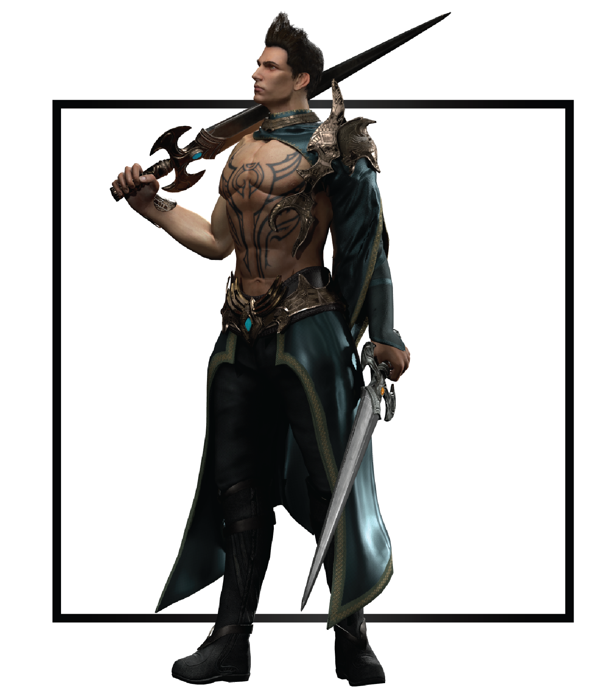

|  |  |
| --- | --- |
| **Name** | Exiel |
| **Title** | Blades of Duality |
| **Realm** | Grynn |
| **Region** | Dashe Tribe |
| **Class** | Reaper |
| **Type** | Melee Physical |
| **Release Date** | Coming Soon |

Externally, Exiel thrived within the Dashe; his innate physical abilities set him apart from all other children, but his psyche began to deteriorate, splitting the edges of his subconscious mind. After ill-fated events, Exiel sought refuge inside the ominous Urakesh forest to hide his younger sister Malaia from the wrath of their tribe. The two soul Gemstones inside him clashed over control of his actions and behaviors, heightening under the pressure of constant external threats and his newfound responsibilities. When circumstances sent him on a rescue mission, Exiel struggled between doing what was right for him and what was best for his people.